Create a Virtual Machine with 1 CPU, 2GB RAM and 15GB storage disk using a Type 2
Virtualization Software using VMware workstation.
Aim: To create and configure a Virtual Machine (VM) with 1 CPU, 2 GB RAM, and 15 GB storage using a Type-2 Hypervisor (VMware Workstation).
Procedure:
- Install VMware Workstation on the host computer.
- Download the Guest Operating System ISO file (Windows/Linux, e.g., Ubuntu).
- Open VMware Workstation.
- Click Create a New Virtual Machine.
- Select Typical (Recommended) and click Next.
- Choose Installer disc image file (ISO) and browse to select the OS ISO file.
- Select the Guest Operating System and its version.
- Enter a Virtual Machine name and choose the storage location.
- Configure hardware settings:
- Processor: 1 CPU
- Memory: 2 GB RA
- Click Finish to create the virtual machine.
- Power on the virtual machine.
- Follow the on-screen instructions to install the guest operating system.
- After installation, install VMware Tools for better performance.
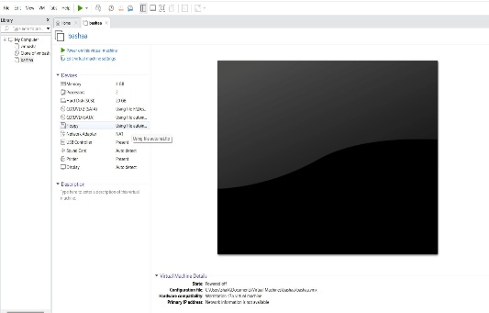
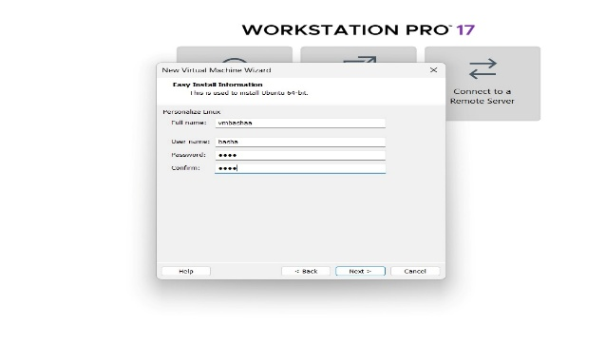
Output:
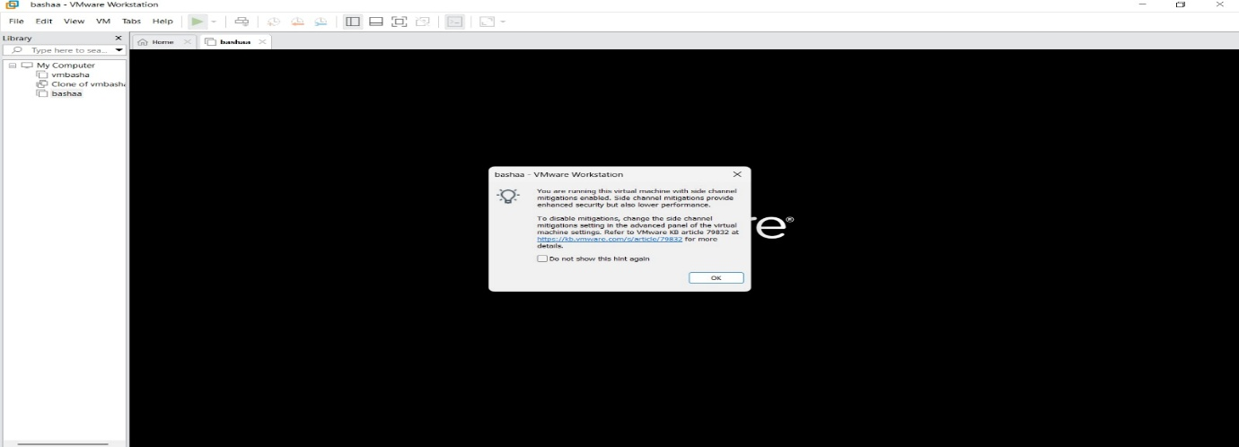
Result: A virtual machine was successfully created using VMware Workstation with 1 CPU, 2 GB RAM, and 15 GB storage disk. The guest operating system ran smoothly within the host system, demonstrating effective virtualization.

